The Impact of Social Media in creating Brand Awareness in the Fast Fashion Industry

Acknowledgements
I am highly obliged to my research supervisor for the successful and timely completion of this research. It was his guidance and directions that helped me in understanding the research methodology and the numerous critical areas of research and thereby, helped me conduct the research in the right direction. I would also express my sincere gratitude to all my teachers and faculty members for their immense contribution to my academic and conceptual learning. I would also thank all respondents who participated in this research for their precious time, cooperation and the valuable contribution of their responses, which helped in developing credible finding through this research. Lastly, I would also like to thank my parents, family members and all my friends for this consistent motivation and support through this research.
Abstract
Over the last few decades, it has been examined that social media is gaining immense popularity as a marketing tool that has enormous potential in helping the brand engage with the customers and help create brand awareness. In this context, this research seeks to examine the impact of social media in creating brand awareness in the fast fashion industry. It analysis the role of social media channels used by leading fashion brands in creating brand awareness in the fast fashion industry, such as Facebook, Instagram, YouTube and Twitter.
For this purpose, mixed-method research is used wherein pragmatism philosophy and deductive approach is followed to determine the methods of data collection and analysis. The data is gathered through qualitative and quantitative methods, wherein survey questionnaire is used for gathering quantitative data and case study is used for gathering qualitative data. The respondents for the survey are composed of 40 millennials from the UK and are selected through convenience sampling method. The findings of the survey are analysis through graphical and correlation analysis, while that of the case study are analysed through thematic analysis.
The findings developed through the quantitative analysis revealed that social media and brand awareness are positively correlated with each other. The findings of the case studies of ASOS and Missguided support these findings and reveal that both companies make comprehensive use of social media tools and platforms, which have been helpful for them in creating brand awareness. Hence, it has been concluded that social media tools and networks used by the fast fashion companies in the UK are beneficial in enhancing brand awareness and influencing the purchase decisions of the consumers.

Table of Contents
Chapter 1: Introduction 6
1.1 Introduction and Background 6
1.2 Aim and Objectives 7
1.3 Research Questions 8
1.4 Significance and Implications of the Study 8
1.5 Research Structure 9
Chapter 2: Literature Review 10
2.1 Introduction 10
2.2 Importance of creating brand awareness in the fast-changing fashion trend of leading and emerging fashion brands 10
2.3 Factors affecting fashion choice or buying preference and the relationship between social media and purchase intention 14
2.4 Extent to which social media support growth and sustainability of leading fashion brands in the fast fashion industry 15
2.5 Use of social media channels by leading fashion brands to create brand awareness in the fast fashion industry 17
2.6 Summary 20
Chapter 3: Research Methodology 21
3.1 Introduction 21
3.2 Research Philosophy 21
3.3 Research Approach 21
3.4 Research Method and Strategy 22
3.5 Data Source and Analysis 23
3.5.1 Data Collection Method 23
3.5.2 Sample Size and Technique 23
3.5.3 Data Analysis Method 24
3.6 Ethical Considerations 24
Chapter 4: Findings, Analysis and Discussion 25
4.1 Findings and Analysis 25
4.1.1 Case Study Analysis: Thematic Analysis 25
Case Study 1: ASOS 25
4.1.2 Survey Analysis – 27
4.2 Discussion 52
Chapter 5: Conclusion and Recommendations 55
5.1 Conclusion 55
5.2 Recommendations 56
5.3 Limitations 57
5.4 Suggestions for Further Research 58
References 59

Chapter 1: Introduction

1.1 Introduction and Background
This research study is about social media that evolves over the years, and influences consumer behaviour and buying decision (Michaela & Lavie orna, 2015). Marketing practices in a contemporary period has considerably changed from the traditional time because of new persuasive channels of marketing; including Search Engine Optimisation Influencer, Cloud, Social media and digital advertisements. These marketing channels help to influence and impact consumer behaviour through two-way communication and easier access to their preferences or feedbacks (Colicev, Malshe & Pauwels, 2018). The positive response and preference of the marketers towards adopting contemporary marketing strategy is widely seen in the industries because advantages of contemporary marketing lead to sustaining brand image and growth.
Within an intensely competitive environment, it is vital to be developed brand equity to attract and retain target customer. Brand awareness indicates to customer's familiarity or recognition with a particular brand or brand name along with its offerings and associated unique selling points (USP) and competitive advantage (Chan, Peters & Marafa, 2016). In a similar context, marketing goal is not selling a product, but it is more focus on telling about the brand in an influential way to promote brand awareness. In a similar context, social media meets essential requirement of marketing through providing brand exposure via interactive communication platform that aids to build a connection with worldwide people or customers (Helal, Ozuem & Lancaster, 2018). Thus, this research project is particularly focused on the fast fashion industry within which social media platforms are largely used to stimulate brand awareness via access of larger audience and customer relationship (Michaela & Lavie orna, 2015). According to the Internet Retailing Report by Skeldon (2019), social media aids the fast fashion industry to attain rapid growth vigorously because of photo sharing by influencers on social media acts as a fashion inspiration for the people specifically youth or millennial generations. The advertisement of the fast fashion trend on social media; such as "variety of outfits" for office, daily, ethnic and party purpose of male, female and kids have been supported brand awareness and buying behaviour of customers. It is because of changing preference of the people as they are likely preferred accessing fashion information from the information sources like social media (Facebook, Instagram, Pinterest, and others) for buying decision of fashion items (Skeldon, 2019). For instance, there are around 6.2 million followers of Zara on Instagram that contribute to brand promotion (Michaela & Lavie orna, 2015, p. 174). Similarly, H&M connected with 8 million or over followers across social media platforms (Helal, Ozuem & Lancaster, 2018, p. 4).
Fashion choices of people with the proliferation of social media have profoundly changed or impacted. The reason is that social media promotes transparent engagement between marketers and customers, and among customers, that is an efficient medium of brand promotion and awareness (Husain, Ghufran & Chaubey, 2016). In the context of social media marketing, this research study has determined the impact of social media in creating brand awareness in the fast fashion industry by considering examples of leading fashion retailers; such as Zara, H&M, Benetton, Next, M&S and ASOS.

1.2 Aim and Objectives
Aim of this study is to determine the impact of social media in creating brand awareness in the fast fashion industry. Objectives of this study to assess the effects of social media on brand awareness are as follow:
- A critical review of the case studies of leading fashion brands in the UK to determine their social media presence and brand awareness
- Examine the relationship between social media and purchase intention based on the empirical or primary data, to identify factors affecting fashion choice or buying preference
- Determine the extent to which social media support growth and sustainability of leading fashion brands in the fast fashion industry

1.3 Research Questions
Main RQ: What is the impact of social media in creating brand awareness in the fast fashion industry?
Sub-Questions
1. How crucial is creating brand awareness in the fast-changing fashion trend of leading and emerging fashion brands?
2. How are social media channels used by leading fashion brands to create brand awareness in the fast fashion industry; such as Facebook, Instagram, YouTube and Twitter?

1.4 Significance and Implications of the Study
The results of this research project are useful for fashion retailers and marketers to understand the way to place and promote the brand to create awareness in the competitive and fast fashion industry. Social media has provided exposure to connect and communicate with the worldwide or global customers and thus; placing of a brand in an influential way is the major requirement to confront competition (Chan, Peters & Marafa, 2016). Brand awareness indicates identification and popularity that contributes to sustaining brand loyalty and relationship. Thus, a good understanding of social media in the context of its impact on creating brand awareness is vital to uphold brand relationship in the long run. Besides this, this study will have good implications for the future academic projects or researchers because a review of different leading fashion retailers’ social media presence and survey data analysis will be useful to gain in-depth insight relationship between social media and brand awareness.

1.5 Research Structure
This research project is integrated the four parts that described as under.
Part 1: Introduction and Literature Review- This part has covered the background context of the research subject along with aim, objectives, research question and significance. In alignment to the mentioned aim and objectives, past academic literature sources (books and journals) are reviewed to present compare and contrast views.
Part 2: Methodology – This part describes layers of the research model, including selection and justification in the alignment of the research purpose.
Part 3: Data analysis and interpretation of results- Survey data is analysed in this part of the research project and interpretation of the respondents’ views in support of the literature evidence.
Part 4: Conclusions and Recommendations- Conclusions are derived to address research objectives and questions. Further, recommendations for fast fashion retailers are provided to take advantage of social media.

Chapter 2: Literature Review

2.1 Introduction
Intense competition and many changes in the fast fashion industry have led to a highly competitive market in the industry. The profit margins have started decreasing, and the competition has become intense (Bhardwaj & Fairhust, 2010, p. 166). The industry is categorised as an industry with relatively quick responses to changes in designing and fashion in consideration of consumers' demands. To that effect, brand awareness and brand loyalty have become very important for growth and sustainability in the fast fashion industry. This has led to an increase in the fast fashion industry's social media involvement and other brands for influencing the buying preferences of consumers. This study aims to analyse the impact of social media in creating brand awareness in the fast fashion industry. The following paragraphs focus on the essentiality of brand awareness in the fast fashion industry, the relevance of social media in creating brand awareness, alongside the ways in which social media aids in the creation of brand awareness in the fast fashion industry. Furthermore, the recommendations for the enhancement of brand awareness created by social media channels in the fast fashion industry are noted, followed by an overall summary.

2.2 Importance of creating brand awareness in the fast-changing fashion trend of leading and emerging fashion brands
In modern times, a business needs to ensure a proper position within the market and create a concrete customer base. According to Foroudi et al. (2018, p. 468), the different ventures need to enhance the brand awareness of the customer base to make them familiar with the quality given an image of a certain brand and their products or services. It is seen that the essentiality of brand awareness creation is vital in the fast-fashion industry to ensure a steady position amidst immense competition. As per Su & Chang (2018, p. 3), brand awareness is defined as the level to which consumers become familiar with the different types of qualities or image of a particular company providing goods and services to the customers. When a buyer recognizes a product correctly just by referring to a brand, the presence of brand awareness is witnessed. With the increase in customer consciousness, it becomes easier for the buyers to associate certain products or services with a concern. As per Khandual & Pradhan (2019, p. 41), the creation of a specified type of brand awareness for any of the consumers is of essential importance as with the help of this concept, a venture drives towards better performance and marketing goals. Additionally, the customers become more aware of the products which help in the company sales in the longer run. In the case of fast fashion concerns, the essentiality to create brand awareness amongst the set of customers is due to the steep competition in the fast fashion market. Mrad, Farah & Haddad (2019, p. 578) opine that due to the constant struggle to attract and retain customers amongst the fast fashion brands such as Zara, H&M, and Forever 21, it becomes imperative for the management of the concerns to create their image in a better manner to attract a customer base. The targeting of the relevant buyer also can be performed through the use of brand awareness creation as the buyers can have a decent idea about the quality and price of the items sold. (Su & Chang 2018, p. 6) opine that the brand image of a company is of pivotal importance to sustain a stable market position for which buyers need to be aware of the brand’s offerings. Through the creation of positive brand awareness, the management can successfully attract customer base through the use of different techniques essential for the fast-fashion company’s growth and development.
According to Huang & Sarigollu (2013), brand awareness is an attribute that helps in bringing positive market outcomes for a product or service of a brand and in aligning equity and marketing mix of the brand to its favour. Brand awareness is not just an essential factor for the brand; it is also related to consumer welfare (Huang & Sarigollu, 2013, p. 5). The brand awareness concept is also aligned with consumers' brand usage experience and the experience perceived by the consumer in association with what was promised and expected and what was received by the brand. This brand awareness is like presenting information about what a brand is providing in the market (Huang & Sarigollu, 2013, p. 5). Comprehending the same, Bilgin (2018), states that informing customers is essential for any brand provided by the brand awareness function of social media marketing activities. This helps in not just informing the qualities of the product or the service but also influencing the product's personal brand profile. This, in turn, helps in spreading and social networking for the brand. (Bilgin, 2018, p. 130). The literature states that brand awareness and brand equity exist in definite link with each other the marketing mix elements used for enhancing brand awareness or drawn through brand equity experience in awareness are considered to be directly correlated in the context of social media marketing (Huang & Sarigollu, 2013, p. 5).
Companies within the fast fashion industry use different means to improve the brand awareness of the customers, out of which the utilisation of social media channels is one of the most pivotal. According to Foroudi et al. (2018, p. 470), the importance of social media in creating brand awareness is vital due to the use of more engaging visual content which can attract an average person over any written content. It is seen that through the use of social media, any company management can create their graphics and images which can attract the customers without any hindrance. However, Shen, Choi & Chow (2017, p. 178), opine that despite the considerable influence of social media over the customer base due to the visual content, the lack of personalised touch in marketing can result in the maintenance of the buyer-seller relationship. The customers have no viable connection with the brand, making it immensely difficult to create brand awareness. Additionally, Bilgin (2018, p. 129) states that sometimes the customers gain inaccurate brand perception which devastates the overall image of the concern, resulting in negative brand awareness. Most of the ventures fear the loss of reputation with a negative image of the brand in the minds of the customers. Nevertheless, with the rise of social media usage, more brands utilise the platform for the enhancement of brand awareness. Statista (2020) website records that the number of social network users have increased from 2.86 billion in 2017 to 3.6 billion in 2020 and is expected to rise to 4.41 billion in 2025. The rise of the social media usage has facilitated the management of the fast-fashion companies with a better way to attract a customer base, in turn creating positive brand awareness. More companies are focused on the creation of positive brand awareness with the use of social media to ensure a secure position of the concern in the market.
Different processes are used by the brand managers of fast-fashion brands to ensure that proper brand awareness is created amongst the set of customers. According to Khandual and Pradhan (2019, p. 43), thorough customer knowledge and adequate importance to buyer opinion, a brand manager can ensure to increase brand awareness through the use of different types of social media channels. Target audience selection should be done with proper consideration of the type of products and services sold. Molinillo et al. (2017, p. 4) state that through an adequate focus on the high-quality visual content with watermark usage, the creation of a suitable strategy can be achieved enabling proper creation of brand awareness. Also, through approaching niche influencers and YouTubers, a brand can reach out to the majority of the customer base to ensure better brand perception amongst the buyers. Campaigns can also be used by the different brand managers to effectively churn out the relevant content for a specified customer group, helping to improve the amount of brand awareness in the varied companies within the fast fashion industry. Fast fashion brands like Forever 21, H&M, and Zara exhibit a very strong media presence which has helped them to attract customers to elevate the number of their sales. Also, these brands have utilised the different eminent personalities for promotion and YouTube campaigns to ensure that most of the customers possess a positive brand image in the market. Zara has over 40 million followers on Instagram, making it one of the most successful brands with a strong social media presence (Instagram, 2020). On the other hand, Forever21 engages with the customers through the use of beauty and fashion influencers and their social media popularity, creating positive brand awareness (Shabbir, AA Khan & SR Khan, 2017, p. 416). Hence, it can be seen that social media possess a very intricate role in the creation of brand awareness in the fast fashion industry.

2.3 Factors affecting fashion choice or buying preference and the relationship between social media and purchase intention
In the view of Nash (2019), factors affecting the buying preference on social media include two major needs; the physical need, that is, the wantonness as well as the self-ideal needs to fulfill the hedonic needs (Nash, 2019, p. 6). It has been ascertained that social media influences the consumer decision-making process for buying in a fashion environment by motivating through the perception of high street fashion. Social media was supposed to influence and inspire consumers to make purchases by guiding the wants and products that very idealistic people are choosing. It has been observed that social media majorly use the content and graphics methodology to influence and affect the buying perception of consumers (Nash, 2019, p. 8). In a similar context, as opined by Hanaysha (2018), corporate social responsibility is another factor that helps in identifying and impacting the behavioural intentions of the consumer towards purchasing behaviour. It is considered that a consumer will positively perceive a brand that has a positive association with corporate social responsibility in its entire working model (Hanysa, 2018, p. 3). In addition, the way social media marketing is used for building and maintaining customer relationships as well as in communicating and engaging consumers influences the buying Preferences of a consumer. Clearly, designs and quality are an essential aspect for attracting consumers' intention towards buying, but visibility is the first step for moving to further steps.
According to Hutter et al. (2013), purchase intentions are highly guided by the marketing strategy chosen by a brand. For instance, marketing activities on social media has been able to influence brand awareness by aligning word of mouth strategies and image of the brand among the prospective consumers (Hutter et al., 2013, p. 344). The purchase intention is guided by three mental stages, such as cognitive, affective, and conative. The literature states that a brand's commitment is what can give the mental image of all of these three. And social media has a very definite relation in guiding the purchase intention of consumers. Social media has become an inevitable part of brands and marketing in recent times; it helps in providing the commitment and satisfaction of buying something which otherwise could not have been useful to the consumer. In addition, it brings that level of awareness and satisfaction that helps in positively changing the buying preference of the consumer (Hutter et al., 2013, p. 344).

2.4 Extent to which social media support growth and sustainability of leading fashion brands in the fast fashion industry
In the view of Phan, Thomas and Heine (2011), social networks and social media for marketing in the world is a new tool for marketing a brand. It supports a brand's sustainability by spreading out the views on brand equity in the market (Phan, Thomas & Heine, 2011, p 213). In addition, the literature states that a clear understanding of the advantages and cope of social media can help enhance the customer’s experience of engaging in the brands and the perceptions and utility that can be achieved from the brand. The communication spread through social media platforms is much expressive than any other marketing platform ((Schivinski & Dabrowski, 2016). These platforms help in encouraging communication between the brands and the consumers and in phasing out any negativity that might have been established by mistake (Phan, Thomas & Heine, 2011, p. 213). In the case of Burberry, for instance, social media strategizing has helped grow the brand towards a new customer segment, that is, the youngsters. It has positioned the social media and its activeness in making the brand more fashionable as well as aspirational for the youngsters to attract young customers. The company recorded a 34% increase in the total revenue by targeting a new segment through social media. Hence, social media can support the growth and sustainability of fashion brands in the fast fashion industry (Phan, Thomas & Heine, 2011, p. 213).
According to Schivinski & Dabrowski (2016), communication effectiveness connected with social media communication is different. The stimuli of perceived knowledge of communication activities in the social media context help in processing consumers' attitudes towards the brand. It states that the communication’s virtual pattern on social media platforms differs from the standard communication patterns and helps generate an overall brand equity judgment for the consumers. The growth of online brands using social media communication patterns and marketing patterns has made it essential to use the social media support system for leading in the fast fashion industry (Schivinski & Dabrowski, 2016). The consistent use of communication, information, and satisfaction perceptions has led to the growth and sustainability of leading fashion brands easily reflected on the social media platform to a great extent. In turn, this has primarily impacted the growth and sustainability of a brand in association with the use of social media platforms (Phan, Thomas & Heine, 2011, p. 213).

2.5 Use of social media channels by leading fashion brands to create brand awareness in the fast fashion industry
Companies within the fashion industry use social media channels to ensure proper creation of brand awareness amongst the customer base. However, irrespective of the constant efforts, the scope of betterment always persists within the brand management. The first recommendation to improve brand awareness through social media channels is developing a voice for the brand over social media handles. Romaniuk, Wight & Faulkner (2017, p. 12) opined that the voice of a brand signifies the communication style of a company which is essential for defining the persona of the company. The communication style in the social media platform should be extremely polite and professional and should provide a considerable analysis of the way in which the brand operates. The voice of the brand should properly define the values for which the company stands (Kim, Choe & Petrick, 2018, p. 327). This voice can help the brand to attract the concerned target audience and project a better brand image, essential for the betterment of the concern. The second recommendation is related to the creation of relatable brand campaigns to improve the organic social media presence. Langaro, Rita, & de Fátima Salgueiro (2018, p. 154) opine that brands need to be more relatable to the customer needs to ensure that more buyers are attracted to their offerings. Also, through relatable brand promotions and campaigns, customers tend to be more impressed, resulting in a positive image of the brand. This kind of brand campaign over social media can help to improve the organic social media presence which can assist the concern to thrive in an extremely competitive environment with a positive brand image. Hence, it can be seen that with betterment in the strategies, a brand can essentially improve their social media presence to improve brand awareness.
As per the insights of Kim & Ko (2012, p. 1481), the fast fashion brands are improving the purchase intention of buyers through social media marketing by improving their chances of purchasing products. For instance, these brands have tie-ups with fashion bloggers who help them in marketing, leading to improvement of purchase intention of customers, which, in turn, enhances brand awareness among customers. In addition to this, the fashion brands target millennials through social media who are one of the most significant customer segments for them as the majority of millennials are active on social media (Kim & Ko, 2012 p 1481). Duffett Mr & Wakeham (2016, p. 22) have stated that the big fast fashion brands such as Gucci and Louis Vuitton are not the only ones, which are generating brand awareness through social media, many fashion designers who own SMEs (Small and Medium Enterprises) create their own fast fashion brand through social media. These independent fashion designers comprehensively use social media to facilitate communication with customers and suppliers, leading to an increase in brand awareness. Due to the power of social media, the SMEs now have the potential to compete with big fashion giants. In the fashion industry, there is a growing role of content creators who helps fashion brands to enhance the customer reach by increasing the popularity of social media post (Duffett Mr & Wakeham, 2016, p. 22).
According to Michaela (2015, pp. 173-174), the fashion industry has registered enormous growth, mainly due to the fast fashion model of business that provides fashionable apparel at nominal prices every few weeks. The fast fashion brands have to respond to the new trends quickly, and they use social media to get the knowledge of the latest fashion. After gaining knowledge, they strive to promptly enhance the awareness of new fashion trends through social media, leading to an increase in revenues (Michaela, 2015, pp. 173-174). In the words of de Lenne & Vandenbosch (2017, p. 14), in today’s era of smartphone and internet revolution, people use social media to gather the information about product or service besides checking reviews of them. Therefore, fast fashion brands extensively use social media to improve the brand image by uploading customer reviews and testimonials on social media, thereby, the generation of brand awareness. Today, fashion-conscious people get fashion ideas mostly from social media, and because of this, it has become one of the most crucial platforms to build customer relationship and to create brand awareness for the fast fashion industry (de Lenne & Vandenbosch, 2017, p. 14).
As per Bilgin (2018), it has been assessed that social media communication channels such as Facebook, Twitter, and Instagram have been found to have a positive effect on the development of brand awareness as well as the brand image. The marketing on social media helps affect the consumer’s behaviour towards purchase intentions (Bilgin, 2018, p. 129). It uses ideas and attitudes along with the description and visualizes the benefits of purchasing a service or product. Social media marketing helps express the contents and benefits of a product or service in a very influential manner and helps create brand awareness and a positive image for the brand. Social media marketing helps in reflecting the authenticity, value, and quality of the goods or services that a specific brand is engaged with. This it does on a virtual platform, a consumer can be satisfied with a brand's product by not even physically visiting it. That is the power of social media. In the fast fashion industry, identity construction is as equally important as brand awareness and brand loyalty. Social media expression helps establish social bonds and depict the identity of a brand, especially in the fast fashion industry. In addition, it also helps in communicating high value and preference of the specific brand compared to other competitors and enhancing loyalty (Bilgin, 2018, p. 130).

2.6 Summary
This paper aimed to analyse the impact of social media in creating brand awareness in the fast fashion industry. It can be seen from the study that the companies need to exhibit a positive brand image to create sustainable brand awareness amongst the customer base in the long run. Additionally, it can be stated that the use of social media, despite having certain complications, possesses vital qualities that can improve a company’s brand image. The utilisation of different processes is implemented by the managers to accentuate the image and presence of a brand to improve the extent of brand awareness which is embedded in the minds of the customers. Lastly, recommendations related to the development of the voice of the brand and relatable brand campaigns are provided for the overall improvement of brand awareness in the future. The independent fashion designers comprehensively use social media to facilitate communication with customers and suppliers, leading to an increase in brand awareness. The fast fashion brands extensively use social media to improve the brand image by uploading customer reviews and testimonials on social media, thereby, the generation of brand awareness.

Chapter 3: Research Methodology

3.1 Introduction
This chapter discusses the methods and tools applied in this research to address the research question. It explains the research philosophy, approach and strategy applied in this research along with the methods of data collection and analysis and presents a justification for their suitability for this research.

3.2 Research Philosophy
The philosophies based on ontological, epistemological and axiological assumptions specifically and strongly emphasise positivism, which relies on objectivism such that relationship between social media and brand awareness in the fast fashion industry can be studied in a critical and independent manner. Nevertheless, the study of the case studies of the companies from fast fashion industry has been developed from the secondary data based on the experiences of the managers and qualitative data and not the real data from the companies. This suggests a significant potential for subjective analysis in their compilation.
Hence, as this research requires an adequate reconciliation and amalgamation of objective and subjective analysis, positivism or interpretvism cannot be applied individually. Therefore, pragmatism is identified as the most appropriate philosophy for this research so that the causal relationship between the research variables can be studied analytically and supported by subjective and qualitative data gathered through case study analysis (Johnson & Duberley, 2000, p. 170).

3.3 Research Approach
This research follows the deductive approach to streamline appropriate reasoning in the research (Schutt, 2018). Deductive approach has been identified suitable for this research because it requires determination of the cause and effect relationship between the two research variables, namely, between social media and brand awareness in the fast fashion industry. Additionally, this research moves from general (impact of social media in creating brand awareness in the fast fashion industry) to specific (social media support growth and sustainability of leading fashion brands in the fast fashion industry). Moreover, the research seeks to contribute to the prevailing theory and literature on social media and the fast fashion industry rather than create a new theory on social media in the fast fashion industry. This aspect has been identified as an essential basis to reject the inductive approach, a theory-building approach (Schutt, 2018).

3.4 Research Method and Strategy
This research follows a mixed-method strategy, wherein qualitative and quantitative methods of data collection and analysis have been combined to help gather credible and reliable data to address the research objectives. In this respect, a survey questionnaire is used as a quantitative method, while case study is used as a qualitative method (Creswell & Clark, 2007, p. 72). However, among the two methods, the quantitative method is the dominating method analysis, whereas the qualitative method is used only to support the findings developed through quantitative data. For an effective application of the mixed methodology, this research follows the explanatory design, which helps in conducting a two-phase mixed methods-based research. Under this design, the qualitative data is used to build upon or explain the primary quantitative findings (Creswell & Clark, 2007, p. 72). Consequently, in this research, the quantitative data has been gathered through a survey questionnaire, followed by the qualitative data gathered through a secondary data-based case study.

3.5 Data Source and Analysis

3.5.1 Data Collection Method
The data for this research is gathered through quantitative and qualitative methods. For this purpose, the quantitative data is gathered through a survey questionnaire conducted with 40 millennials, who are highly active at social media networks and platforms and have a lot of interest in fast fashion. The survey was conducted online, wherein a survey questionnaire consisting of 26 closed-ended questions was uploaded on the website and its link was shared with the respondents, who were asked to fill the questionnaire and submit it online. The survey questionnaire was developed through LSBU Qualtrics survey and aimed at gathering data regarding important variables such as social media, brand awareness, social media platforms, fast fashion brands, and others. In this respect, a number of measurement scales were applied, such as interval scale and nominal non-metric scale. Few questions also involved the Rating scale, Likert scale and matrix questions.
The qualitative data was gathered on the cases of two fast fashion brands from the UK on their usage of social media tools and their impact on the brands’ brand awareness among the customers. The data for these case studies were gathered from a range of secondary sources, including books, media reports, marketing reports of the fast fashion brands such as Missguided, Asos and Pretty Little Thing.

3.5.2 Sample Size and Technique
The sample for this research was composed of males and females between the ages 18 and 35 years. The population in this age bracket is identified for this research because they are believed to be highly active and updated on social media platforms and interested in the fashion industry. The selection of the 40 respondents from this identified population was made through social media, mostly Instagram, Facebook and WhatsApp. The research followed a non-probability sampling method, wherein a convenience sampling technique was used to select the sample population for the survey (Lavrakas et al., 2019).

3.5.3 Data Analysis Method
The findings gathered from the survey questionnaire were quantified through MS Excel software and analysed through SPSS software. The measurement techniques applied in the research to determine the causal relationship between the social media and brand awareness of fast fashion brands in the UK were correlation and regression (Bryman & Cramer, 2002, p. 169). Additionally, graphical and descriptive analysis was also used to present the findings. In respect of the case study, the data gathered through the secondary sources was analysed through thematic analysis (Guest, MacQueen & Namey, 2012, p. 10).

3.6 Ethical Considerations
The findings gathered from the survey questionnaire were quantified through MS Excel software and analysed through SPSS software. The measurement techniques applied in the research to determine the causal relationship between the social media and brand awareness of fast fashion brands in the UK were correlation and regression (Bryman & Cramer, 2002, p. 169). Additionally, graphical and descriptive analysis was also used to present the findings. In respect of the case study, the data gathered through the secondary sources was analysed through thematic analysis (Guest, MacQueen & Namey, 2012, p. 10).

Chapter 4: Findings, Analysis and Discussion

4.1 Findings and Analysis

4.1.1 Case Study Analysis: Thematic Analysis

Case Study 1: ASOS
ASOS has been way ahead of the competition in the field of digital and social media marketing. It uses social media not just for enhancing visibility and for creating awareness, but it appropriately uses the social strategy to reach the hearts of millions of fans. It posts at least 2 to 3 visual updates on the Facebook platform every day to grab more attention. It keeps active on other social media sites like Twitter and Pinterest as well to engage a more significant number of consumers actively. Similarly, it allows deep penetration of loyalty in driving its sales by devising a social platform that addresses all issues (Marketing Society, 2020). Collectively, it uses a user-generated content along with discounting and visual methodology for attracting consumers and for spreading awareness among the consumers.
Impact of social media on the brand awareness of ASOS in the UK
Social media platforms' development has enhanced the presence and profitability of various luxury brands on the internet in the virtual world. It has brought a drastic change to the environment affecting the behavior and expectations of customers. It has been observed in the case of UK High Street retailing brand ASOS that there was a growth in sales due to the presence on the internet. Social media has helped in accelerating the pace of targeting customers by increasing the brand's accessibility to those who could not access it before (Nash, 2019, p. 03). It has also influenced the comprehension and acceptability and visibility of the brand in the modern-day consumer environment for ASOS in the UK. This is because of the positive influence of social media on enhancing the brand's awareness and guiding a favorable attitude and perception of the brand among the consumers.
Case Study 2: Missguided
Social media presence of Missguided in the UK
Misguided has very well tapped into the e-commerce market by creating an extensive content in the social media marketing using attractive content on social media platforms. The brands following on the social media has increased to a large extent and more than £206 million in revenue has been earned in the year 2017 which is 75% more than the revenue last year. The biggest innovation pattern of social media marketing endorsed by misguided has been influencer market and the influential marketing has helped in driving engagement and building loyalty of the customers on all the social media platforms (Nicholson, 2017). On the other hand, it has equally tried to engage customers by frequently speaking to the customers on the issues and to engage them more.
Impact of social media on the brand awareness of Missguided in the UK

Fashion retailer misguided has been using social media platforms in very innovative ways to grow their online presence in association with impacting the brand awareness among the consumers in the UK. It has recently invested in public relations marketing to give effect to the branding and awareness for its brand. The strategy of creative content marketing has helped in acquisition precisely what is required from digital marketing, pushing the boundaries, and looking forward to growth (Ben, 2019). It has been observed that the revenue itself is an indicator of the increase in brand awareness as impacted by the active availability of the brand on social media platforms (Nichoslon, 2017).

4.1.2 Survey Analysis –
In this study, primary data has been analysed with the help of descriptive analysis, and correlation test in SPSS software along with the thematic analysis.
Descriptive Analysis

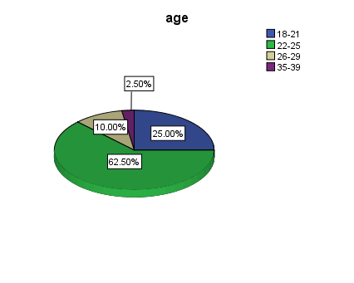
Chart 1

In the study, respondents were asked about their age group and it can be analysed from the results that 63% of respondents are aged between 22 to 25 years (refer appendix table 1). It shows that majorly all the participants are young and are aged between18 to 25 years.

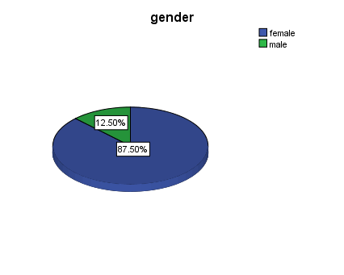
Chart 2

It can be analysed from the statistical data that the majority of the respondents in the study are females (refer appendix table 2).
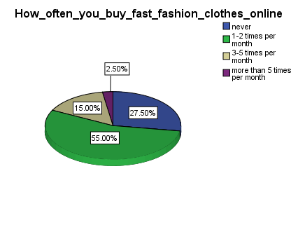
Chart 3

The respondents were asked about the number of times they purchase clothes online and it can be analysed that 55% of respondents buy online clothes once or twice in a month (refer appendix table 3). It implies that more than half of the respondents often purchase clothes online.

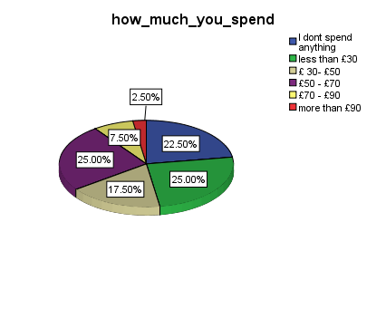

Chart 4

In the study, the respondents were asked about how much money they spend every month for online purchasing and it shows that 25% of respondents spend 50 to 70£ (refer appendix table 4). It shows that many participants spend a large amount of money on online purchasing.

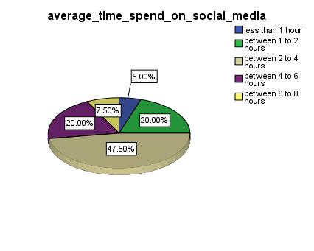

Chart 5

The participants were asked about the average time they spend on social media platforms and it can be analysed that 48% participants spend around 2 to 4 hours on social media (refer appendix table 5). It shows that majority of the respondents are active on social media and atleast spend 3 hours daily on it.

The respondents were asked on which social media platforms they are most active and it can be analysed from the data that the majority of the respondents are active on Facebook and Instagram (refer appendix table 6). It can be reported that Facebook and Instagram are the most popular social media platforms on which the majority of the users are active.

which_fast_fashion_brands_you_follow_on_facebook
 |  | Frequency | Percent | Valid Percent | Cumulative Percent
Valid | None | 34 | 85.0 | 85.0 | 85.0
Valid | Asos, Boohoo | 1 | 2.5 | 2.5 | 87.5
Valid | Pretty Little Thing, Boohoo | 1 | 2.5 | 2.5 | 90.0
Valid | Pretty Little Thing, Asos, Missguided, Boohoo | 1 | 2.5 | 2.5 | 92.5
Valid | Pretty Little Thing, Asos, Missguided | 1 | 2.5 | 2.5 | 95.0
Valid | Missguided, None | 1 | 2.5 | 2.5 | 97.5
Valid | Pretty Little Thing, Asos, Missguided, Boohoo, Misspap, Oh Polly, Missy Empire | 1 | 2.5 | 2.5 | 100.0
Valid | Total | 40 | 100.0 | 100.0
Table 7

In the study, the respondents were asked about which fashion brands they follow on Facebook and the statistical data shows that only a few respondents follow online fashion brands on Facebook. All the brands, namely Pretty Little Things, Asos, Boohoo and Missguided, are mostly followed by the entire range of Facebook followers (see above table).

which_fast_fashion_brand_you_follow_on_Instagram
 |  | Frequency | Percent | Valid Percent | Cumulative Percent
Valid | None | 22 | 55.0 | 55.0 | 55.0
Valid | Pretty Little Thing, Asos, Missguided | 5 | 12.5 | 12.5 | 67.5
Valid | Pretty Little Thing | 1 | 2.5 | 2.5 | 70.0
Valid | Pretty Little Thing, Asos, Missguided, Boohoo | 2 | 5.0 | 5.0 | 75.0
Valid | Asos, Boohoo | 1 | 2.5 | 2.5 | 77.5
Valid | Asos, Missguided | 1 | 2.5 | 2.5 | 80.0
Valid | Pretty Little Thing, Asos, Missguided, Boohoo, Oh Polly | 1 | 2.5 | 2.5 | 82.5
Valid | Pretty Little Thing, Missguided | 1 | 2.5 | 2.5 | 85.0
Valid | Pretty Little Thing, Asos, Missguided, Boohoo, Misspap | 1 | 2.5 | 2.5 | 87.5
Valid | Pretty Little Thing, Asos, Missguided, Boohoo, Misspap, I saw it first, Oh Polly, In the Style | 1 | 2.5 | 2.5 | 90.0
Valid | Pretty Little Thing, Asos, Missguided, Oh Polly | 2 | 5.0 | 5.0 | 95.0
Valid | Missguided | 1 | 2.5 | 2.5 | 97.5
Valid | Asos | 1 | 2.5 | 2.5 | 100.0
Valid | Total | 40 | 100.0 | 100.0
Table 8

In the study, the respondents were asked about which fashion brands they follow on Instagram and it can be analysed that majorly respondents follow Pretty Little Things, Asos and Misguided (see above table).

which_fast_fashion_brand_you_follow_on_Youtube
 |  | Frequency | Percent | Valid Percent | Cumulative Percent
Valid | none | 36 | 90.0 | 90.0 | 90.0
Valid | Oh Polly | 1 | 2.5 | 2.5 | 92.5
Valid | Asos, Boohoo | 1 | 2.5 | 2.5 | 95.0
Valid | Pretty Little Thing, Asos, Missguided | 1 | 2.5 | 2.5 | 97.5
Valid | Asos | 1 | 2.5 | 2.5 | 100.0
Valid | Total | 40 | 100.0 | 100.0

Table 9

In the study, respondents were asked about the fashion brands they follow on Youtube and it can be analysed that respondents follow Oh Polly, Asos, Boohoo, Missguided and Pretty Little Things on Youtube (see above table).

which_fast_fashion_brands_you_follow_on_Snapchat
 |  | Frequency | Percent | Valid Percent | Cumulative Percent
Valid | None | 37 | 92.5 | 92.5 | 92.5
Valid | Pretty Little Thing, None | 1 | 2.5 | 2.5 | 95.0
Valid | Pretty Little Thing | 1 | 2.5 | 2.5 | 97.5
Valid | In the Style | 1 | 2.5 | 2.5 | 100.0
Valid | Total | 40 | 100.0 | 100.0

Table 10

In the study, respondents were asked about which fashion brands they follow on Snapchat and it can be analysed that respondents majorly follow Pretty Little Things on Snapchat (see above table).

which_fast_fashion_brand_you_follow_on_twitter
 |  | Frequency | Percent | Valid Percent | Cumulative Percent
Valid | none | 38 | 95.0 | 95.0 | 95.0
Valid | Pretty Little Thing, Asos, Missguided, Boohoo | 1 | 2.5 | 2.5 | 97.5
Valid | Pretty Little Thing, Missguided | 1 | 2.5 | 2.5 | 100.0
Valid | Total | 40 | 100.0 | 100.0
Table 11

In the study, respondents were asked about which fashion brands they follow on Twitter and it can be analysed that respondents follow Asos, Boohoo, Missguided and Pretty Little Things on Twitter (see above table).

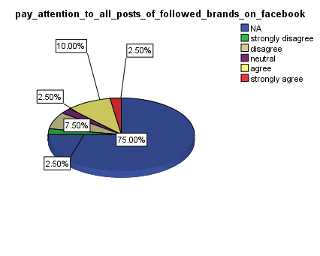

Chart 6

In the study, the respondents were asked if they pay attention to all the posts of followed brands on Facebook, and the data shows that around 10% respondents agree to the point while 8% respondents disagree (see above figure and refer appendix table 12). It implies that majority of the respondents pay attention to the online posts of their followed brands on Facebook.

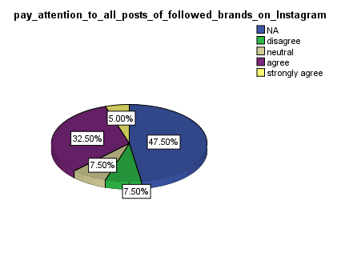

Chart 7

The participants were asked if they pay attention to the online posts of their followed brands on Instagram. Around 33% of participants agreed that they pay attention to the online posts of their followed brand while 8% of participants disagreed (see above figure and refer appendix table 13). It implies that the majority of respondents pay attention to the online posts of their followed brands on Instagram.

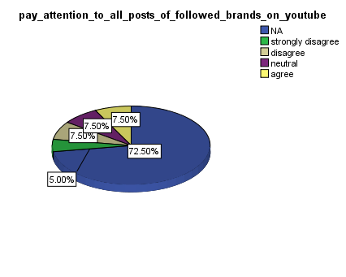
Chart 8

The participants were asked if they pay attention to all the posts of their followed brands on Youtube and it can be analysed from the data that equal proportion of participants agree and disagree on the point (see above figure and refer appendix table 14). It shows that half of the participants pay attention to the Youtube posts of their followed brands while the rest of the half do not.

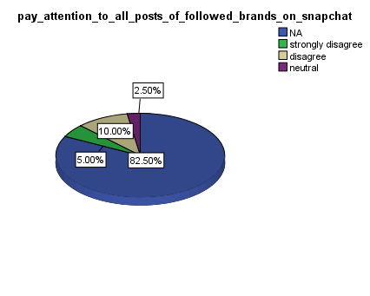

Chart 9

The respondents were asked if they pay attention to online posts of their followed brands on Snapchat and it can be analysed from the data that no respondent pays attention to the online posts of their followed brands on Snapchat (see above figure and refer appendix table 15).

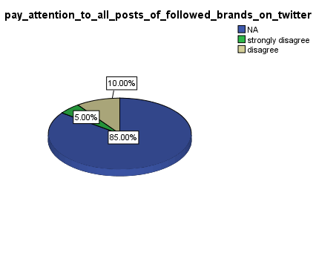

Chart 10

The participants were asked if they pay attention to the posts of their followed brands on Twitter and the data shows that no participant pays attention to the online posts of their followed brands on Twitter (see above figure and refer appendix table 16).

brands_should_post_new_content
 |  | Frequency | Percent | Valid Percent | Cumulative Percent
Valid | not important | 2 | 5.0 | 5.0 | 5.0
Valid | slightly important | 2 | 5.0 | 5.0 | 10.0
Valid | somewhat important | 6 | 15.0 | 15.0 | 25.0
Valid | very important | 17 | 42.5 | 42.5 | 67.5
Valid | extremely important | 13 | 32.5 | 32.5 | 100.0
Valid | Total | 40 | 100.0 | 100.0

Table 17
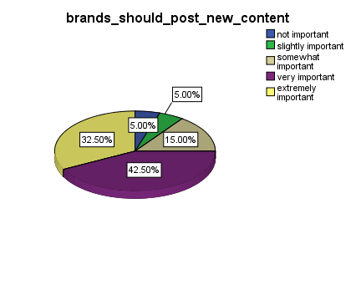

Chart 11
The respondents were asked how important it is for them that the brands they follow should often post new content. Around 43% of respondents reported that it is very important that brands often post new content while only 5% of respondents think that it is not important for them (see above figure). It implies that the majority of respondents think that brands should often post new content and it is very important for them.

brands_should_post_information_about_products
 |  | Frequency | Percent | Valid Percent | Cumulative Percent
Valid | not important | 1 | 2.5 | 2.5 | 2.5
Valid | slightly important | 1 | 2.5 | 2.5 | 5.0
Valid | somewhat important | 4 | 10.0 | 10.0 | 15.0
Valid | very important | 15 | 37.5 | 37.5 | 52.5
Valid | extremely important | 19 | 47.5 | 47.5 | 100.0
Valid | Total | 40 | 100.0 | 100.0

Table 18
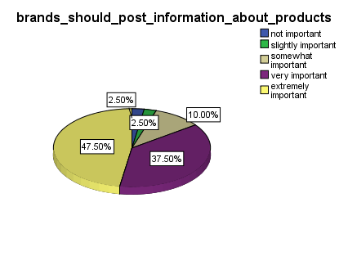

Chart 12

The respondents were asked as to how important it is for them that the brands they follow should post information and details of the product. Around 48% respondents reported that it is extremely important that brands post information about products while only 3% respondents think that it is not important for them if brands post information about the products or not (see above figure). It implies that the majority of respondents think that it is very important for them that brands post information about products.
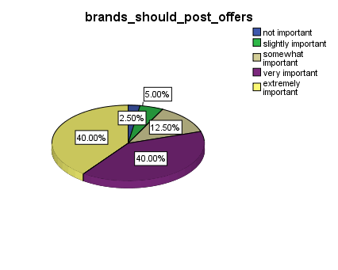

Chart 13

In the study, the respondents were asked if it is important for them that their followed brands post about offers. Around 40% of respondents think it is very important, while other 40% of respondents think it is extremely important for them that their followed brands post about offers run by them (see above figure and refer appendix table 19). It implies that it is very important for the respondents that brands keep posting about different offers.

your_purchasing_decision_is_affected_by_posts_on_social_media
 |  | Frequency | Percent | Valid Percent | Cumulative Percent
Valid | not important | 4 | 10.0 | 10.0 | 10.0
Valid | slightly important | 3 | 7.5 | 7.5 | 17.5
Valid | somewhat important | 13 | 32.5 | 32.5 | 50.0
Valid | very important | 14 | 35.0 | 35.0 | 85.0
Valid | extremely important | 6 | 15.0 | 15.0 | 100.0
Valid | Total | 40 | 100.0 | 100.0

Table 20
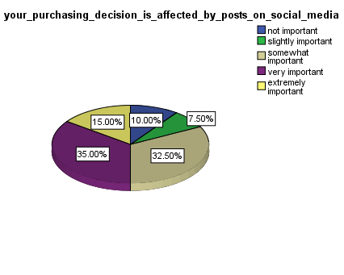

Chart 14

In the study, the participants were asked how important are the posts and comments of different people on social media platforms while making purchasing decisions. It has been analysed that for 35% respondents, the posts and comments on social media are very important and they affect their purchasing decision while for 10% respondents, comments and social media posts are not important for shaping their purchase decision (see above figure).

advertisments_on_social_media_impacts_your_purchasing_decision
 |  | Frequency | Percent | Valid Percent | Cumulative Percent
Valid | not important | 4 | 10.0 | 10.0 | 10.0
Valid | slightly important | 5 | 12.5 | 12.5 | 22.5
Valid | somewhat important | 12 | 30.0 | 30.0 | 52.5
Valid | very important | 13 | 32.5 | 32.5 | 85.0
Valid | extremely important | 6 | 15.0 | 15.0 | 100.0
Valid | Total | 40 | 100.0 | 100.0

Table 21
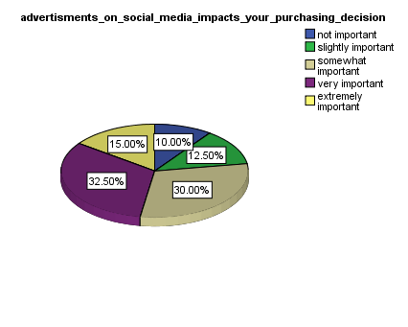

Chart 15

In the study, the participants were asked about the importance of advertisements on a social media platform that affect their purchasing decision. Around 33% of respondents find advertisement very important, while 10% of respondents do not find them important (see above figure). It implies that the majority of respondents think that advertisements are important and they affect their purchasing decision.

you_identify_logo_of_brands_as_they_are_present_on_social_media
 |  | Frequency | Percent | Valid Percent | Cumulative Percent
Valid | NA | 13 | 32.5 | 32.5 | 32.5
Valid | strongly disagree | 4 | 10.0 | 10.0 | 42.5
Valid | Disagree | 1 | 2.5 | 2.5 | 45.0
Valid | Neutral | 5 | 12.5 | 12.5 | 57.5
Valid | Agree | 4 | 10.0 | 10.0 | 67.5
Valid | strongly agree | 13 | 32.5 | 32.5 | 100.0
Valid | Total | 40 | 100.0 | 100.0
Table 22

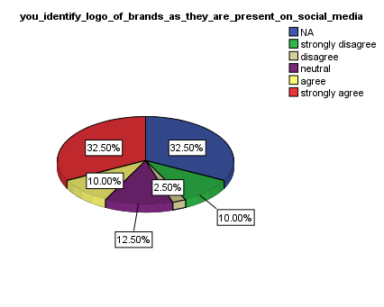

Chart 16

The respondents were asked whether they easily identify the logo of different brands as they are active on social media platforms. Around 33% of respondents strongly agree on the point, while only 10% of respondents strongly disagree to the point (see above figure). It shows that majority of respondents are active on social media platforms and can easily identify logos of different online brands.

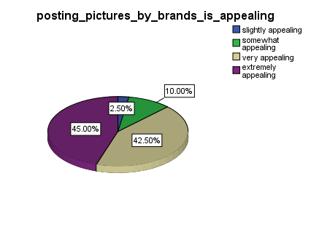

Chart 17
In the study, the participants were asked about how appealing the pictures of fashionable outfits posted by online brands are and in response, 45% respondents think that pictures posted by online brands are extremely appealing while only 3% respondents think that pictures are slightly appealing (see above figure and refer appendix table 23).

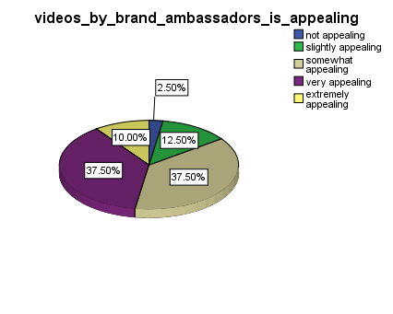
Chart 18

In the study, the participants were asked about how appealing the videos of brand ambassador posted by online brands are and 38% respondents think that videos of brand ambassadors posted by online brands are extremely appealing while only 3% respondents think that such videos are slightly appealing (see above figure and refer appendix table 24).
Correlation Test

Correlations
 |  | How_often_you_but_fast_fashion_clothes_online | advertisments_on_social_media_impacts_your_purchasing_decision
How_often_you_buy_fast_fashion_clothes_online | Pearson Correlation | 1 | .354*
How_often_you_buy_fast_fashion_clothes_online | Sig. (2-tailed) |  | .025
How_often_you_buy_fast_fashion_clothes_online | N | 40 | 40
advertisments_on_social_media_impacts_your_purchasing_decision | Pearson Correlation | .354* | 1
 | Sig. (2-tailed) | .025
 | N | 40 | 40
*. Correlation is significant at the 0.05 level (2-tailed).
Table 25

Correlations
 |  | you_identify_logo_of_brands_as_they_are_present_on_social_media | How_often_you_but_fast_fashion_clothes_online
you_identify_logo_of_brands_as_they_are_present_on_social_media | Pearson Correlation | 1 | .515**
 | Sig. (2-tailed) |  | .001
 | N | 40 | 40
How_often_you_but_fast_fashion_clothes_online | Pearson Correlation | .515** | 1
How_often_you_but_fast_fashion_clothes_online | Sig. (2-tailed) | .001
How_often_you_but_fast_fashion_clothes_online | N | 40 | 40
**. Correlation is significant at the 0.01 level (2-tailed).
Table 26

In the study, the correlation test has been applied to identify if the variables are related or not. The table 25 shows that p-value for correlation test is 0.025 less than 0.05 which shows the statistical significance of the test and the value of Pearson correlation coefficient (0.354) indicates that there is a positive correlation between the facts “ how often people buy clothes online” and “advertisements affect purchasing decision”.
Similarly, table 26 shows the p-value for the test as 0.001, which is less than 0.05 and it implies that the test is statistically significant. The value of the Pearson correlation coefficient (0.515) indicates a strong positive correlation between the variables "how often people buy clothes online" and "people identify the logo of famous online brands".

4.2 Discussion
In respect of the first objective related to the case studies of various UK fashion brands to determine their social media presence and brand awareness, it is discussed in the report that the brand awareness and media presence plays a crucial role for every type of business entity to achieve market goals and better performance of the company (Khandual & Pradhan, 2019, p 41). In the same context, the findings of the study identified that it becomes crucial for the management of various companies such as H&M, Zara, and Forever 21 to foster their brand image to attract a large number of customers (Mrad, Farah & Haddad 2019, p 578). Further, from the case study of ASOS and Missguided, it is found out that both companies are opting the social media platforms to create brand awareness. The collection of primary data, it is identified that a major part of the population is actively engaged and spends their time on Instagram, which in turn helps fashion brands in fostering their brand image.
In relation to the second objective of the relationship between social media and purchase intention to identify factors affecting fashion choice or buying preference, the study after collecting the primary data has found out that social media marketing plays a crucial role in improving the buyer's purchase intention. Additionally, the findings also reflect that the fashion brands tie-up with the various fashion bloggers, which in turn helps in marketing the fashionable products and thereby fostering the customers buying intention. The findings also assert that the fashion brands directly target the millennials since these are actively engaged on social media platforms. Further, millennials are one of the customer segments that play a crucial role in fostering the profitability and enriching the image of the fashion brands (Kim & Ko, 2012 p 1481). The giant fashion brands like Gucci and Louis are not only using social media instead SMEs are incorporating the social media practice in their business strategy to promote the brand of the product and thereby attract a wide number of customers (Wakeham, 2016 p 22).
In the context of the third objective related to the extent to which the social media support growth and sustainability of leading fashion brands in the fast fashion industry, the examination of the findings highlights that the fashion industry has seen enormous growth with the help of providing fashionable products at an affordable price to the customers. The use of social media helps in getting the knowledge of the latest fashion among the customers, which in turn fosters the profitability (Michaela, 2015, pp. 173-174). The study also asserts that the increasing use of mobile devices allows the customers to gather any details about products on a single click. These findings suggests that use of social media platforms by fast fashion products helps them in attracting the massive customers, which in turn facilitates the fashion brands in achieving the objective of growth, sustainability, and brand awareness. Further, it is also found out from the primary data that approximately 10% of people that are attached to Facebook pay attention to the posts that are made by the fast fashion brands, which in turn provides some benefit to the fashion brands.

Chapter 5: Conclusion and Recommendations

5.1 Conclusion
The aim of this research is to determine the impact of social media in creating brand awareness in the fast fashion industry. In this respect, the findings gathered for the first objective of the research revealed that social media has been playing a highly crucial role in supporting the fast fashion companies to raise brand awareness, educate the customers regarding their products, engage with the customers and establish a strong brand image and position in the minds of the customers. The case studies of two leading fast fashion brands, namely ASOS and Missguided support these findings and confirm that both the brands make comprehensive use of social media platforms to make the customer aware and this strategy has been highly beneficial for the two brands in enhancing its brand image and brand awareness among the customers. In the context of the second objective that sought to examine the relationship between social media and purchase intention, it has been assessed that a significant majority of the surveyed respondents agreed that social media posts and advertisements on social media affect their purchase decisions to a significant extent. This has motivated the fast fashion brands to incorporate social media platforms on their business and marketing strategy for brand promotion.
In the context of the third objective, the research findings confirm that social media has been highly supportive and beneficial for the fast fashion industry in reaching the customers and addressing their demands. It has been observed from the research findings that the majority of the respondents agree that the use of logos on social media platforms help them in engaging more effectively with the brand. The respondents pay attention to all the posts of the brands they follow on the social media platforms such as Twitter, Instagram and Youtube and it helps them in gaining awareness about the brand. Posting of pictures and videos on social media by these brands appeals the customers to a significant extent. Hence, in light of the findings of the correlation analysis, thematic analysis and literature review, it can be concluded that social media platforms are helpful in creating brand awareness for the fast fashion industry.

5.2 Recommendations
The adoption of social media channels is a good marketing strategy that helps fashion brands in expanding their businesses and fostering revenues. The fashion brands with the help of various social media channels can attract a wide number of customers with the help of exploration of the new markets. The various social media channels are mentioned below with the help of which fashion brands can achieve their goal of brand awareness.
- The leading fashion brands should use Instagram for the purpose of promoting their products as it is the fastest growing social media platform that helps in presenting the products to a wide range of targeted customers. The ads on Instagram, putting stories about the fashion over there, and showing the fashionable content will facilitate the fashion brands in popularising and creating the brand awareness of the fashionable products (Bug, 2019). The way the content is reflected over Instagram also plays a crucial role in attracting a wide number of users and thereby the fashion brands must quote the sophisticated and inspirational quotes that will help in grasping the customers at a rapid rate and achieving the brand awareness objective.
- Facebook is also another social media channel that helps in connecting society and sharing their ideas in a greater manner. The fashion brands should develop the Facebook page for the purpose of presenting the newest collection of the products to the target customers (Management Association, 2014). This in turn will provide the connected feeling with the customers. Further, the presentation of images of the fashionable products that are put on the real people and not by models and dummies will immensely win the heart of the customers, which in turn helps the companies in grasping the customers at an early rate. Moreover, the Facebook page is also a good option for fashion brands. The presentation of the fashion stories, types of fashionable products, and other details related to fashion on the Facebook page would enhance the interest of the customers, which in turn helps the fashion brands in creating brand awareness with more ease.
- The support service to the customers also helps the fashionable brands in fostering brand awareness. It is not just about to sell fashionable products to the customers and generate profitability. In order to achieve the long term success and achieve the brand awareness objective, it is crucial for the companies to bring support services for the customers in order to resolve their queries. The negative comment put by the customers may affect the brand of the company and thus the company should take care of such support services in an effective manner. The fashion brands should incorporate the feature of support services across the companies’ websites in order to provide a swift response over the customers’ comments (Pappas et al., 2019). The quick and swift response helps the company in building a good image in the customer's mind, which in turn facilitates in building the brand image of the fashion brand.

5.3 Limitations
One of the most significant limitations in respect of this research was that focus on a number of variables in the research objectives, such as brand awareness, purchase intention, growth, sustainability hampered the scope and direction of the research. While the findings focus specifically on the relationship between social media and brand awareness of fast fashion companies in the UK, the other factors could not be studied in such detail and preciseness because of the limitation of time and scope. Additionally, fast fashion companies being a very newly emerging sector of the fashion industry, there is limited secondary data accessible regarding these brands. Consequently, the case studies could not be studied critically and in detail. These aspects leave scope for further analysis in this area of research.

5.4 Suggestions for Further Research
In respect of future research, it is suggested that a critical comparison between two or more social media platforms can be made to determine which platform is more popular among the audience and effective in gaining customer attention and influencing their purchase decision. Another important context of research in this area in future could be a comparison between the fast fashion brands in two more countries regarding the usage and effectiveness of social media on brand awareness and purchase decisions of the consumers. This will help in gaining broader perspectives and explore more innovative applications of social media marketing being practised by fast fashion brands across the world.

References
Ben, S 2019, Missguided Eyes UK and US Growth with New SEO Supoort, Essential retail, retrieved 19 August 2020, < https://www.essentialretail.com/news/missguided-new-seo-agency/>
Bhardwaj, V, & Fairhurst, A 2010, ‘Fast Fashion: Response To Changes In The Fashion Industry. The International Review Of Retail’ Distribution And Consumer Research, vol. 20, pp.165-173. < https://www.tandfonline.com/doi/abs/10.1080/09593960903498300>
Bilgin, Y 2018, ‘The effect of social media marketing activities on brand awareness, brand image and brand loyalty’, Business & Management Studies: An International Journal, vol. 6, no. 1, pp. 128-148. <http://www.bmij.org/index.php/1/article/view/839>
Bryman, A & Cramer, D 2002, Quantitative Data Analysis with SPSS Release 10 for Windows: A Guide for Social Scientists, Routledge.
Bug, P 2019, Fashion and Film: Moving Images and Consumer Behavior, London: Springer Nature.
Chan, CS, Peters, M & Marafa, LM 2016, ‘An assessment of place brand potential: familiarity, favourability and uniqueness’, Journal of Place Management and Development, vol. 9, no. 3, pp. 269-288. < https://www.emerald.com/insight/content/doi/10.1108/JPMD-01-2016-0003/full/html>
Colicev, A, Malshe, A & Pauwels, K 2018, ‘Social media and customer-based brand equity: an empirical investigation in retail industry’, Administrative Sciences, vol. 8, no. 55, pp. 1-15. < https://www.mdpi.com/2076-3387/8/3/55/htm>
Creswell, JW & Clark, VLP 2007, Designing and Conducting Mixed Methods Research, SAGE.
de Lenne, O. & Vandenbosch, L 2017, ‘Media and sustainable apparel buying intention, Journal of Fashion Marketing and Management: An International Journal, vol. 21, no. 4, pp.1-30.< https://www.emerald.com/insight/content/doi/10.1108/JFMM-11-2016-0101/full/html>
Duffett Mr, R.G. & Wakeham Dr, M 2016, ‘Social media marketing communications effect on attitudes among millennials in South Africa’, The African Journal of Information Systems, vol. 8, no. 3 , p.2.< https://digitalcommons.kennesaw.edu/ajis/vol8/iss3/2/>
Foroudi, P, Jin, Z, Gupta, S, Foroudi, MM & Kitchen, PJ 2018, ‘Perceptional components of brand equity: Configuring the Symmetrical and Asymmetrical Paths to brand loyalty and brand purchase intention’, Journal of Business Research, vol. 89, pp. 462-474. <https://www.sciencedirect.com/science/article/pii/S0148296318300316>
Guest, G, MacQueen, KM & Namey, EE 2012, Applied Thematic Analysis, SAGE.
Hanaysha, JR 2018, ‘ An examination of the factors affecting consumer’s purchase decision in the Malaysian retail market’. PSU Research Review, vol. 2, pp. 01-113. <http://eprints.bournemouth.ac.uk/30793/3/Paper.%20version%20submitted%20Social%20media%20influences%20on%20fashion%20consumers_paper%20.pdf>
Helal, G, Ozuem, W & Lancaster, G 2018, ‘Social media brand perceptions of millennials’, International Journal of Retail & Distribution Management, vol. 46, no. 10, pp. 1-18. <http://eprints.glos.ac.uk/5980/1/5980-Ozuem-%282018%29-Social_media_brand_perceptions.pdf>
Huang, R, & Sarigollu, E 2014, ‘How Brand Awareness Relates To Market Outcome, Brand Equity, And The Marketing Mix’ Fashion Branding and Consumer Behaviors, pp. 113-132. < https://link.springer.com/chapter/10.1007/978-1-4939-0277-4_8>
Husain, S, Ghufran, A & Chaubey, DS 2016, ‘Relevance of social media in marketing and advertising’, Splint International Journal of Professionals, vol. 3, no. 7, pp.21-28.< https://www.researchgate.net/profile/Dhani_Chaubey2/post/Could_someone_please_let_me_know_a_ground_theory_that_shows_the_relationship_between_social_media_marketing_and_brand_equity/attachment/59d6471879197b80779a2046/AS%3A460988249055232%401486919571789/download/Relevance+of+Social+media+in+marketing+and+advertising.pdf >
Hutter, K, Hautz, J, Dennhardt, S, & Füller, J 2013, ‘The Impact Of User Interactions In Social Media On Brand Awareness And Purchase Intention: The Case Of MINI On Facebook’ Journal Of Product & Brand Management vol. 22, pp. 342-351. <https://d1wqtxts1xzle7.cloudfront.net/41504975/The_impact_of_user_interactions_in_social_media_on_brand_awareness_and_purchase_intention.pdf?1453633640=&response-content-disposition=inline%3B+filename%3DJournal_of_Product_and_Brand_Management.pdf&Expires=1597837294&Signature=deGWG9HGErdSC5BfRApEZ3Tl7RbeSXbffXOdLGKwe4R-IBYks3GLqRPt4ER7yP3CZ7oO05QPEqH47NRWQPeIVxYIcaNf-JG7Jlqo2MUpHZMJpzHKRAWx7aEtIZBgw1VFDlfuSXzgI7VIF6E05auEfa-GeFHK9J1QuLafJtqbaDDYdZXJem7KQo80C5QUY7grzf7euNgttFVssvtCQ8zgqr~nHgeS8w~nHslPXX3kgHofZTCMdPJ2yaNYF1oitEAFEH8PbtrSA57qUMAyEyJjHW8Sfp7L65lVJ3DiLz8oeKACWCv7hZ9LiIR9MZvc7t33VxN-ahgA0N7O25cIVm4Fzw__&Key-Pair-Id=APKAJLOHF5GGSLRBV4ZA>
Instagram 2020, Zara, Instagram, retrieved 22 July 2020, <https://www.instagram.com/zara/?hl=en>
Johnson, P & Duberley, J 2000, Understanding Management Research: An Introduction to Epistemology, SAGE.
Khandual, A & Pradhan, S 2019, ‘Fashion brands and consumers approach towards sustainable fashion’, In Fast fashion, fashion brands and sustainable consumption (pp. 37-54). Springer, Singapore. <https://link.springer.com/chapter/10.1007/978-981-13-1268-7_3>
Kim, A.J. & Ko, E 2012, ‘Do social media marketing activities enhance customer equity? An empirical study of luxury fashion brand’, Journal of Business research, vol. 65, no. 10, pp.1480-1486. < https://www.sciencedirect.com/science/article/abs/pii/S0148296311003584>
Kim, SS, Choe, JYJ & Petrick, JF 2018, ‘The effect of celebrity on brand awareness, perceived quality, brand image, brand loyalty, and destination attachment to a literary festival’, Journal of Destination Marketing & Management, vol. 9, pp. 320-329. <https://www.sciencedirect.com/science/article/pii/S2212571X16303031>
Langaro, D, Rita, P & de Fátima Salgueiro, M 2018, ‘Do social networking sites contribute for building brands? Evaluating the impact of users' participation on brand awareness and brand attitude’, Journal of Marketing Communications, vol. 24, no. 2, pp. 146-168. <https://www.tandfonline.com/doi/abs/10.1080/13527266.2015.1036100>
Lavrakas, PJ, Traugott, MW, Kennedy, C, Holbrook, AL, Leeuw, ED & West, BT 2019, Experimental Methods in Survey Research: Techniques that Combine Random Sampling with Random Assignment, John Wiley & Sons.
Management Association 2014, Digital Arts and Entertainment: Concepts, Methodologies, Tools, and Applications: Concepts, Methodologies, Tools, and Applications, Pennsylvania: IGI Global.
Marketing Society 2020, Think Piece, Marketing Societyx <https://econsultancy.com/how-asos-uses-facebook-twitter-pinterest-and-google/>
Michaela, E 2015, ‘Fashion conscious consumers, fast fashion and the impact of social media on purchase intention’, Academic Journal of Interdisciplinary Studies, vol. 3, no. 3 S1 , p.173.< https://www.mcser.org/journal/index.php/ajis/article/view/8365>
Molinillo, S, Japutra, A, Nguyen, B & Chen, CHS 2017, ‘Responsible brands vs active brands? An examination of brand personality on brand awareness, brand trust, and brand loyalty’, Marketing Intelligence & Planning. <https://www.emerald.com/insight/content/doi/10.1108/MIP-04-2016-0064/full/html>
Mrad, M, Farah, MF & Haddad, S 2019, ‘From Karl Lagerfeld to Erdem: a series of collaborations between designer luxury brands and fast-fashion brands’, Journal of Brand Management, vol. 26, no. 5, pp. 567-582. <https://link.springer.com/article/10.1057/s41262-018-00146-2>
Nash, J 2019, ‘Exploring how social media platforms influence fashion consumer decisions in the UK retail sector’, Journal of Fashion Marketing and Management: An International Journal, pp.01-113. <http://eprints.bournemouth.ac.uk/30793/3/Paper.%20version%20submitted%20Social%20media%20influences%20on%20fashion%20consumers_paper%20.pdf>
Nicholson, B 2017, How Missguided redefines what it means for a brand to go viral, Newswhip, retrieved 19 August 2020, <https://www.newswhip.com/2018/08/missguided-innovated-ecommerce-marketing/>
Pappas, IO, Mikalef, P, Dwivedi, YK, Jaccheri, L, Krogstie, J & Mäntymäki, M 2019, Digital Transformation for a Sustainable Society in the 21st Century, London: Springer Nature.
Phan, M, Thomas, R, & Heine, K 2011, ‘Social Media And Luxury Brand Management: The Case Of Burberry’ Journal of Global Fashion Marketing, vol. 2, pp. 213-222. <https://www.researchgate.net/profile/Michel_Phan/publication/271626015_Social_Media_and_Luxury_Brand_Management_The_Case_of_Burberry/links/556688ef08aeccd77735a457/Social-Media-and-Luxury-Brand-Management-The-Case-of-Burberry.pdf>
Romaniuk, J, Wight, S & Faulkner, M 2017, ‘Brand awareness: revisiting an old metric for a new world’, Journal of Product & Brand Management. <https://www.emerald.com/insight/content/doi/10.1108/JPBM-06-2016-1242/full/html?fullSc=1&fullSc=1&mbSc=1>
Schivinski, B, & Dabrowski, D 2016, ‘The Effect Of Social Media Communication On Consumer Perceptions Of Brands’ Journal Of Marketing Communications, vol. 24, pp.189-214. <https://eprints.bbk.ac.uk/19939/1/19939.pdf>
Schutt, RK 2018, Investigating the Social World: The Process and Practice of Research, SAGE Publications.
Shabbir, MQ, Khan, AA & Khan, SR 2017, ‘Brand loyalty brand image and brand equity: the mediating role of brand awareness’, International journal of innovation and applied studies, vol. 19, no. 2, p. 416. <https://www.researchgate.net/profile/Muhammad_Qasim_Shabbir/publication/311914186_BRAND_LOYALTY_BRAND_IMAGE_AND_BRAND_EQUITY_THE_MEDIATING_ROLE_OF_BRAND_AWARENESS/links/5862599708ae6eb871ab14fb/BRAND-LOYALTY-BRAND-IMAGE-AND-BRAND-EQUITY-THE-MEDIATING-ROLE-OF-BRAND-AWARENESS.pdf>
Shen, B, Choi, TM & Chow, PS 2017, ‘Brand loyalties in designer luxury and fast fashion co-branding alliances’, Journal of Business Research, vol. 81, pp.173-180. <https://www.sciencedirect.com/science/article/pii/S0148296317302138>
Skeldon, P 2019, Social influencers have led to the rise in fast fashion, with 30% of shoppers using Instagram for inspiration, Internet Retailing, retrieved 11 August 2020, < https://internetretailing.net/mobile-theme/mobile-theme/social-influencers-have-led-to-the-rise-in-fast-fashion-with-30-of-shoppers-using-instagram-for-inspiration-20388>
Statista 2020, Number of social network users worldwide from 2017 to 2025(in billions), Statista, retrieved 22 July 2020, <https://www.statista.com/statistics/278414/number-of-worldwide-social-network-users/>
Su, J & Chang, A 2018, ‘Factors affecting college students’ brand loyalty toward fast fashion’, International Journal of Retail & Distribution Management. <https://www.emerald.com/insight/content/doi/10.1108/IJRDM-01-2016-0015/full/html>
Appendix

Age
 |  | Frequency | Percent | Valid Percent | Cumulative Percent
Valid | 18-21 | 10 | 25.0 | 25.0 | 25.0
Valid | 22-25 | 25 | 62.5 | 62.5 | 87.5
Valid | 26-29 | 4 | 10.0 | 10.0 | 97.5
Valid | 35-39 | 1 | 2.5 | 2.5 | 100.0
Valid | Total | 40 | 100.0 | 100.0
Table 1

Gender
 |  | Frequency | Percent | Valid Percent | Cumulative Percent
Valid | female | 35 | 87.5 | 87.5 | 87.5
Valid | male | 5 | 12.5 | 12.5 | 100.0
Valid | Total | 40 | 100.0 | 100.0

Table 2
How_often_you_buy_fast_fashion_clothes_online
 |  | Frequency | Percent | Valid Percent | Cumulative Percent
Valid | Never | 11 | 27.5 | 27.5 | 27.5
Valid | 1-2 times per month | 22 | 55.0 | 55.0 | 82.5
Valid | 3-5 times per month | 6 | 15.0 | 15.0 | 97.5
Valid | more than 5 times per month | 1 | 2.5 | 2.5 | 100.0
Valid | Total | 40 | 100.0 | 100.0

Table 3

how_much_you_spend
 |  | Frequency | Percent | Valid Percent | Cumulative Percent
Valid | I don't spend anything | 9 | 22.5 | 22.5 | 22.5
Valid | less than £30 | 10 | 25.0 | 25.0 | 47.5
Valid | £ 30- £50 | 7 | 17.5 | 17.5 | 65.0
Valid | £50 - £70 | 10 | 25.0 | 25.0 | 90.0
Valid | £70 - £90 | 3 | 7.5 | 7.5 | 97.5
Valid | more than £90 | 1 | 2.5 | 2.5 | 100.0
Valid | Total | 40 | 100.0 | 100.0

Table 4

average_time_spend_on_social_media
 |  | Frequency | Percent | Valid Percent | Cumulative Percent
Valid | less than 1 hour | 2 | 5.0 | 5.0 | 5.0
Valid | between 1 to 2 hours | 8 | 20.0 | 20.0 | 25.0
Valid | between 2 to 4 hours | 19 | 47.5 | 47.5 | 72.5
Valid | between 4 to 6 hours | 8 | 20.0 | 20.0 | 92.5
Valid | between 6 to 8 hours | 3 | 7.5 | 7.5 | 100.0
Valid | Total | 40 | 100.0 | 100.0
Table 5
you_are_active_on_which_social_media_platforms
 |  | Frequency | Percent | Valid Percent | Cumulative Percent
Valid | Facebook, Instagram | 10 | 25.0 | 25.0 | 25.0
Valid | Facebook, Instagram, Youtube, Snapchat, Twitter and others | 1 | 2.5 | 2.5 | 27.5
Valid | Instagram | 4 | 10.0 | 10.0 | 37.5
Valid | Instagram, Snapchat | 1 | 2.5 | 2.5 | 40.0
Valid | Instagram, Snapchat, Twitter | 1 | 2.5 | 2.5 | 42.5
Valid | Facebook, Instagram, Youtube, Snapchat | 7 | 17.5 | 17.5 | 60.0
Valid | Facebook, Instagram, Snapchat | 1 | 2.5 | 2.5 | 62.5
Valid | Facebook, Instagram, Twitter | 1 | 2.5 | 2.5 | 65.0
Valid | Facebook, Instagram, Youtube | 3 | 7.5 | 7.5 | 72.5
Valid | Instagram and others | 1 | 2.5 | 2.5 | 75.0
Valid | Instagram, Youtube | 2 | 5.0 | 5.0 | 80.0
Valid | Instagram, Youtube, Snapchat | 1 | 2.5 | 2.5 | 82.5
Valid | Instgram, Youtube, Snapchat, Twitter | 1 | 2.5 | 2.5 | 85.0
Valid | Facebook, Instagram, Snapchat, Twitter | 1 | 2.5 | 2.5 | 87.5
Valid | Facebook, Instgram, Youtube, Snapchat, Twitter | 5 | 12.5 | 12.5 | 100.0
Valid | Total | 40 | 100.0 | 100.0
Table 6
pay_attention_to_all_posts_of_followed_brands_on_facebook
 |  | Frequency | Percent | Valid Percent | Cumulative Percent
Valid | NA | 30 | 75.0 | 75.0 | 75.0
Valid | strongly disagree | 1 | 2.5 | 2.5 | 77.5
Valid | disagree | 3 | 7.5 | 7.5 | 85.0
Valid | neutral | 1 | 2.5 | 2.5 | 87.5
Valid | agree | 4 | 10.0 | 10.0 | 97.5
Valid | strongly agree | 1 | 2.5 | 2.5 | 100.0
Valid | Total | 40 | 100.0 | 100.0

Table 12
pay_attention_to_all_posts_of_followed_brands_on_Instagram
 |  | Frequency | Percent | Valid Percent | Cumulative Percent
Valid | NA | 19 | 47.5 | 47.5 | 47.5
Valid | Disagree | 3 | 7.5 | 7.5 | 55.0
Valid | Neutral | 3 | 7.5 | 7.5 | 62.5
Valid | Agree | 13 | 32.5 | 32.5 | 95.0
Valid | strongly agree | 2 | 5.0 | 5.0 | 100.0
Valid | Total | 40 | 100.0 | 100.0
Table 13

pay_attention_to_all_posts_of_followed_brands_on_youtube
 |  | Frequency | Percent | Valid Percent | Cumulative Percent
Valid | NA | 29 | 72.5 | 72.5 | 72.5
Valid | strongly disagree | 2 | 5.0 | 5.0 | 77.5
Valid | disagree | 3 | 7.5 | 7.5 | 85.0
Valid | neutral | 3 | 7.5 | 7.5 | 92.5
Valid | agree | 3 | 7.5 | 7.5 | 100.0
Valid | Total | 40 | 100.0 | 100.0
Table 14

pay_attention_to_all_posts_of_followed_brands_on_snapchat
 |  | Frequency | Percent | Valid Percent | Cumulative Percent
Valid | NA | 33 | 82.5 | 82.5 | 82.5
Valid | strongly disagree | 2 | 5.0 | 5.0 | 87.5
Valid | disagree | 4 | 10.0 | 10.0 | 97.5
Valid | neutral | 1 | 2.5 | 2.5 | 100.0
Valid | Total | 40 | 100.0 | 100.0
Table 15

pay_attention_to_all_posts_of_followed_brands_on_twitter
 |  | Frequency | Percent | Valid Percent | Cumulative Percent
Valid | NA | 34 | 85.0 | 85.0 | 85.0
Valid | strongly disagree | 2 | 5.0 | 5.0 | 90.0
Valid | Disagree | 4 | 10.0 | 10.0 | 100.0
Valid | Total | 40 | 100.0 | 100.0
Table 16

brands_should_post_offers
 |  | Frequency | Percent | Valid Percent | Cumulative Percent
Valid | not important | 1 | 2.5 | 2.5 | 2.5
Valid | slightly important | 2 | 5.0 | 5.0 | 7.5
Valid | somewhat important | 5 | 12.5 | 12.5 | 20.0
Valid | very important | 16 | 40.0 | 40.0 | 60.0
Valid | extremely important | 16 | 40.0 | 40.0 | 100.0
Valid | Total | 40 | 100.0 | 100.0

Table 19

posting_pictures_by_brands_is_appealing
 |  | Frequency | Percent | Valid Percent | Cumulative Percent
Valid | slightly appealing | 1 | 2.5 | 2.5 | 2.5
Valid | somewhat appealing | 4 | 10.0 | 10.0 | 12.5
Valid | very appealing | 17 | 42.5 | 42.5 | 55.0
Valid | extremely appealing | 18 | 45.0 | 45.0 | 100.0
Valid | Total | 40 | 100.0 | 100.0

Table 23
videos_by_brand_ambassadors_is_appealing
 |  | Frequency | Percent | Valid Percent | Cumulative Percent
Valid | not appealing | 1 | 2.5 | 2.5 | 2.5
Valid | slightly appealing | 5 | 12.5 | 12.5 | 15.0
Valid | somewhat appealing | 15 | 37.5 | 37.5 | 52.5
Valid | very appealing | 15 | 37.5 | 37.5 | 90.0
Valid | extremely appealing | 4 | 10.0 | 10.0 | 100.0
Valid | Total | 40 | 100.0 | 100.0

Table 24

